Muhammad Umar Farooq 9:31 to 9:51
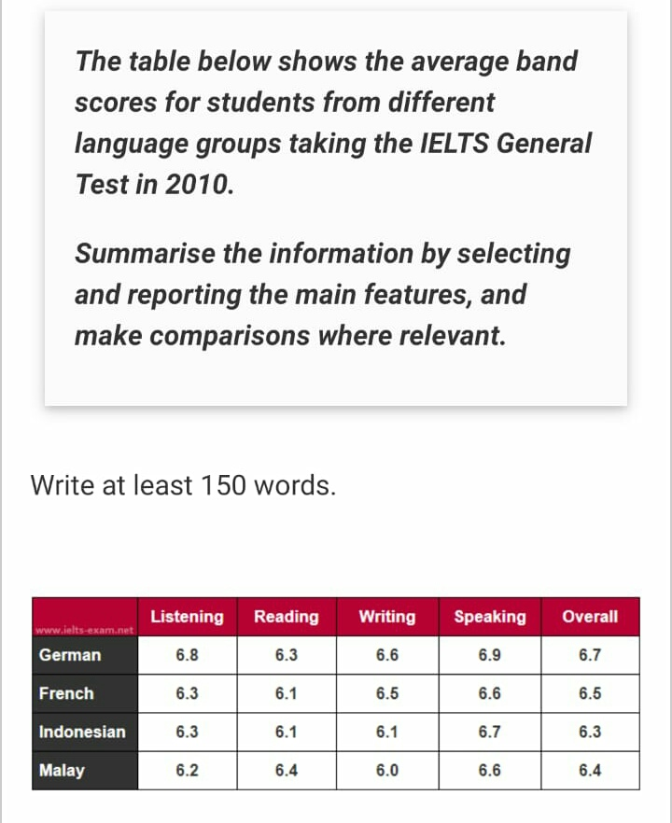
The provided table illustrates the statistical mean band score for students from Germany, France, Indonesia, and Malay who took the IELTS General Test in 2010.
Overall, the table provides information about the students who do not have English as a first language and appeared in the IELTS General Test. German students get higher bands in contrast to other countries from the list fourth of these countries have overall band scores in the IELTS General Test between 6 bands to 7 bands.
Looking at the details, German students had 6.8 in Listening, 6.3 in Reading, 6.6 in Writing, 6.9 in Speaking, and overall, 6.7 bands in the IELTS general test in 2010. Furthermore, French students had the second-highest band score in 2010, with an overall score of 6.5 and above 6 in each module. Moreover, Malaysian students ranked third, with an overall band score of 6.4 and over 6 in every module.
Lastly, Indonesian students came into the picture with 6.3 overall bands in the IELTS General Test and maintained higher than 6 bands in different sections in 2010.

